Digital Tactical Control
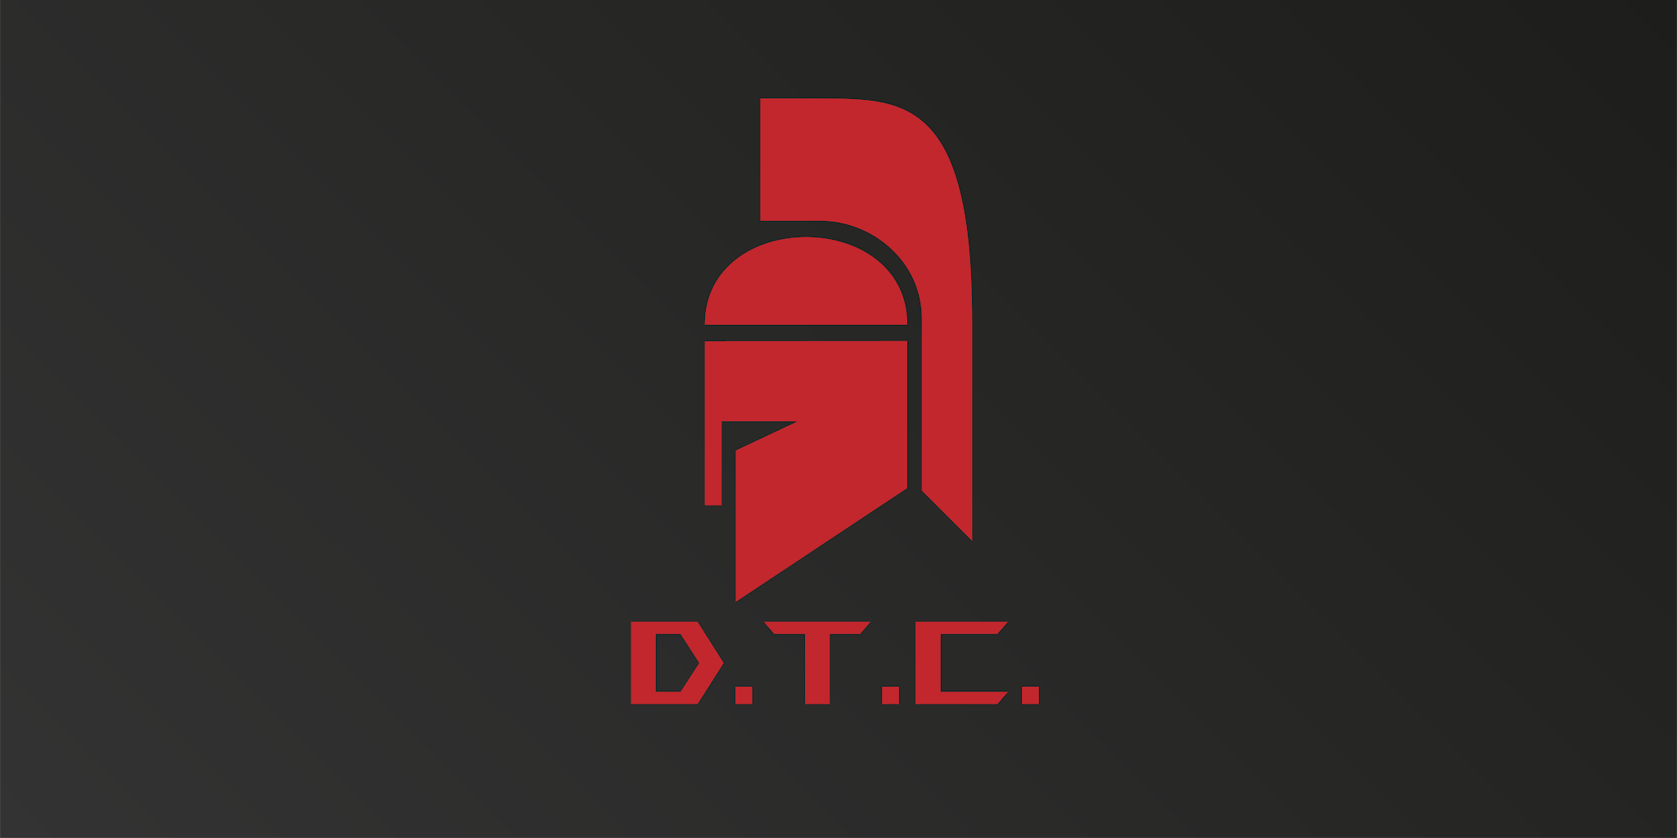

Objectives
Unlike other corporations, your success in Procatorion is less likely to be measured in whether you make money (important though that will be) more in how well you can replicate the success of Multi-States United.
It's an open secret that there is no love lost between you and the Gordon Corporation since Multi-States United blocked their expansion into Citadel. The Gordon Corporation has a penchant for pettiness. Be wary.

Starting resources
- Political Will - your reputation precedes you, and you are not trusted. Your Political Will begins at 7
- Income - With your continued operations and existing governmental contracts, you have plenty of reserves and passive income. Your Income begins at 13, and you start with 27 Credits
- Facilities - you begin with the following Facilities
  - 1 research Facility
  - 1 corporate Facility
  - 2 security Facilities
  - 1 arms Facility
- Protection Cards - you begin with the following Protection Cards:
  - 4 copies of Security team
  - 4 copies of Keypad
  - 4 copies of Security Shutter
  - 4 copies of Orc
  - 3 copies of Roboscorpion
  - 3 copies of Angel
- Facility contents - you begin with the Arms technology. This gives you the ability to build Arms Facilities that increase the strength of your Physical Protection cards.

